

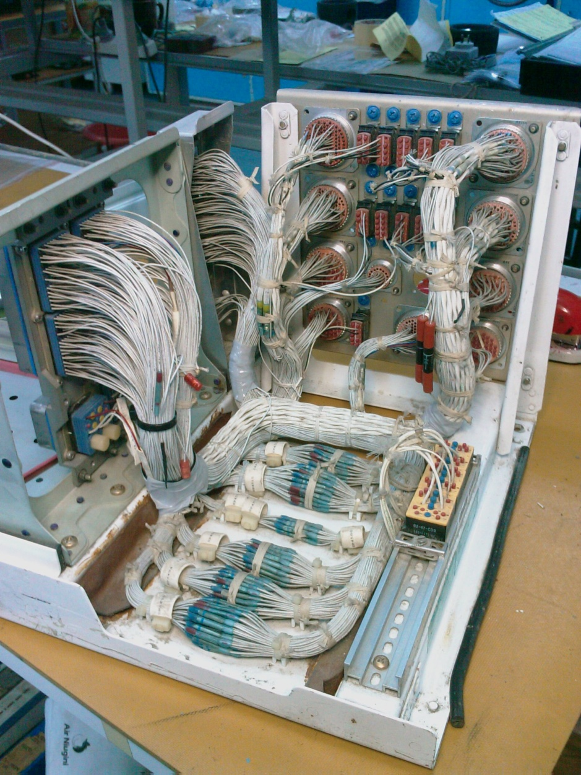

WIRE PULLERS CLUB
Benefits and details of Membership

MEMBERSHIP STRUCTURE
Joining (Once only) $ 200.00 (Does not include membership)
Annual Membership $ 100.00 (Includes one nominated aircraft registration)
1st Additional Aircraft $ 75.00 1st additional nominated aircraft registration. (Due with initial and each Annual Membership)
2nd and Subsequent Aircraft $ 50.00 per nominated aircraft registration.
(Due with initial and each Annual Membership)

BENEFITS OF MEMBERSHIP
SERVICE | MEMBERS |  | NON-MEMBERS
SERVICE | RAAus | VH – A/C | RAAus | VH – A/C
DEFECT RECTIFICATION | $ 60.00/Hr | $ 70.00/Hr | $ 70.00/Hr (LAME)  $ 65.00/Hr (AME) | $ 90.00/Hr (LAME)  $ 70.00/Hr (AME)
INSTALLATION | $65.00/Hr | $ 75.00/Hr | $ 75.00/Hr (LAME)  $ 70.00 (AME) | $ 95.00/Hr (LAME)  $ 75.00/Hr (AME)
FLAT RATE FEE SERVICES | 10% OFF |  | NO DISCOUNT
TELEPHONE SUPPORT 24/7 | FREE |  | FIRST 15 MINS FREE THEN $ 65.00/Hr
TRAVEL TIME (GROUND) | $ 25.00/Hr |  | $ 35.00/Hr
TRAVEL TIME (AIR) | $ 40.00/Hr + (A/C COST) |  | $ 50.00/Hr + (A/C COST + 15%)
EQUIPMENT SALES INSTALLED BY PK AVIATION | 10% OFF |  | NO DISCOUNT
EQUIPMENT SALES WALK AWAY | 5% OFF |  | NO DISCOUNT
SHIPPING FOR SPECIAL ORDERS or BENCH REPAIRS | COST |  | COST + 15%

PURPOSE OF THE CLUB
The purpose of the PK Aviation Wire Pullers Club is to simply offer dedicated PK Aviation customers discounts on goods and services in recognition of their dedication to having their aircraft maintained by PK Aviation.
There is no implied social content, although events may be organised from time to time for members. Events such as product launches and customer appreciation days may be held.
The membership is purely voluntary.
MEMBERSHIP RULES
- Membership Joining Fee is payable at time of initial application.
- Membership renewals are due each year on the anniversary of first joining date.
- Additional aircraft fee is payable at each renewal each year.
- Fees do NOT include GST
- Proof of aircraft ownership is required at initial application and at each renewal.
- Aircraft greater than 5700Kgs are not eligible for inclusion.
- Memberships that have been lapsed for more than 12 months will have to repay the current Joining Fee to reactivate membership.
- Membership can only be cancelled by providing written advice to PK Aviation. No refunds will be given.
- Invoices are to be paid in accordance with the PK Aviation standard invoice statement.
- Travel expenses remain unchanged and are as applicable to the PK Aviation Recruiting - Schedule of Fees, current revision.
NOTE:
PK Aviation reserves the right to amend the club rules at any time without notice and it is the responsibility of the member to review the Wire Pullers Club page on the PK Aviation website from time to time to ensure they are fully conversant with any changes or omissions.

